- The UK is planning one of the largest fiscal consolidations of any advanced economy over the next two years. We expect it to result in much weaker GDP growth than the Office for Budget Responsibility forecasts and think the government's balance sheet is still likely to deteriorate.
- The evidence suggests consolidations need to be carefully designed to succeed, especially if the global economic climate is uncertain. Around half of fiscal adjustments fail, and even successful ones often rely on policies like expansionary monetary policy, structural reforms, the compression of large risk premia, and boosts to private sector confidence via 'credibility effects'.
- Consolidations based on cutting government spending are more likely to reduce deficits and are associated with better growth outcomes. The failure rate for adjustments based on revenue raising is high, given the risk of dampening growth prospects without yielding material improvements to the public finances.
- We believe the design of the UK's fiscal adjustment looks out of line with these historical lessons. Roughly 80% of the planned cut in the structural primary deficit is based on revenue-raising measures – a policy mix that is similar to that seen in unsuccessful adjustments. Accompanying policies don't appear particularly supportive of successful adjustment either – growth-boosting structural reforms look minor, monetary policy conditions are likely to remain restrictive for a prolonged period, and trade policy uncertainty is set to rise.
- Yet, with current plans already involving real terms spending cuts for unprotected government departments, there's limited scope for the Chancellor to pursue a path that more closely aligns with international best practice. This serves to highlight the need for the current government to make tangible progress towards improving public sector productivity in order to lower future spending requirements.
Chart 1: The UK's planned fiscal tightening is very large by international standards
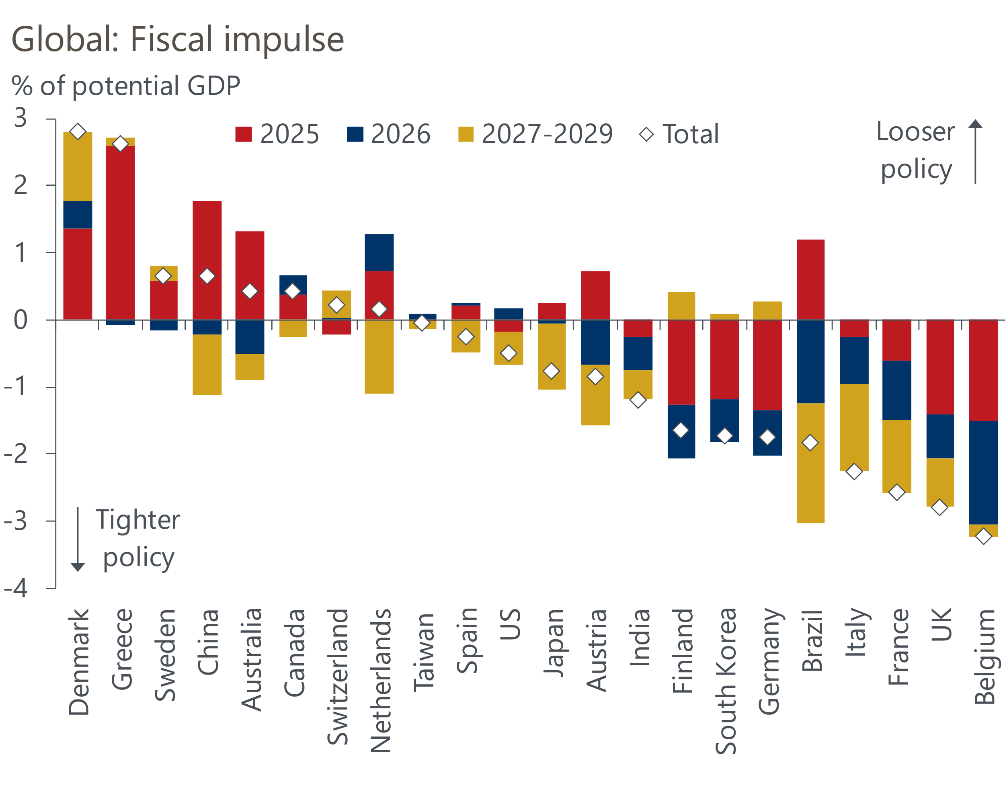
Source: Oxford Economics, Haver Analytics

The UK is planning a substantial tax-driven consolidation
Much of the media commentary around October's Budget focused on the fact that policy was being loosened compared to the plans inherited from the previous government. But this ignored the fact that the previous plans assumed a large tightening of fiscal policy. At 2.8% of GDP over the course of the parliament, the current plans imply that the UK will undergo one of the largest fiscal consolidations of the advanced economies, with most of the tightening due to occur in 2025 and 2026 (Chart 1).
The bulk of the tightening during this parliament is set to come from higher taxes. There are two main sources of higher tax revenues. Most personal tax thresholds and allowances have been frozen in cash terms since April 2021 and are currently set to remain frozen until the end of FY2027-2028. And employers' national insurance contributions will rise in April 2025, with the main rate increasing by 1.2ppts to 15%, and the threshold at which firms must start paying the tax will be cut to £5,000 from £9,100.
On the spending side, overall departmental spending is set to increase by just 1.5% a year in real terms until FY2029-2030. A multi-year Spending Review is due to be published in the summer, which will set out specific departmental allocations. The OBR has calculated that unprotected departments are likely to experience real terms cuts. Meanwhile, capital spending is on course to remain broadly flat as a percentage of GDP, though this is already relatively low by international standards.
The structural primary balance, which excludes the impact of debt interest payments, points to a tightening of around 2.8% of potential GDP in the current parliament, which is some way above the 1.9% consolidation seen during the FY2010-2015 episode (Chart 2). It should be noted that the actual consolidation in FY2010-2015 turned out differently compared with initial plans, and this was partly due to a drop in debt interest payments.
Chart 2: Hefty taxes rises mean policy will become more restrictive than during the FY2010-2015 episode
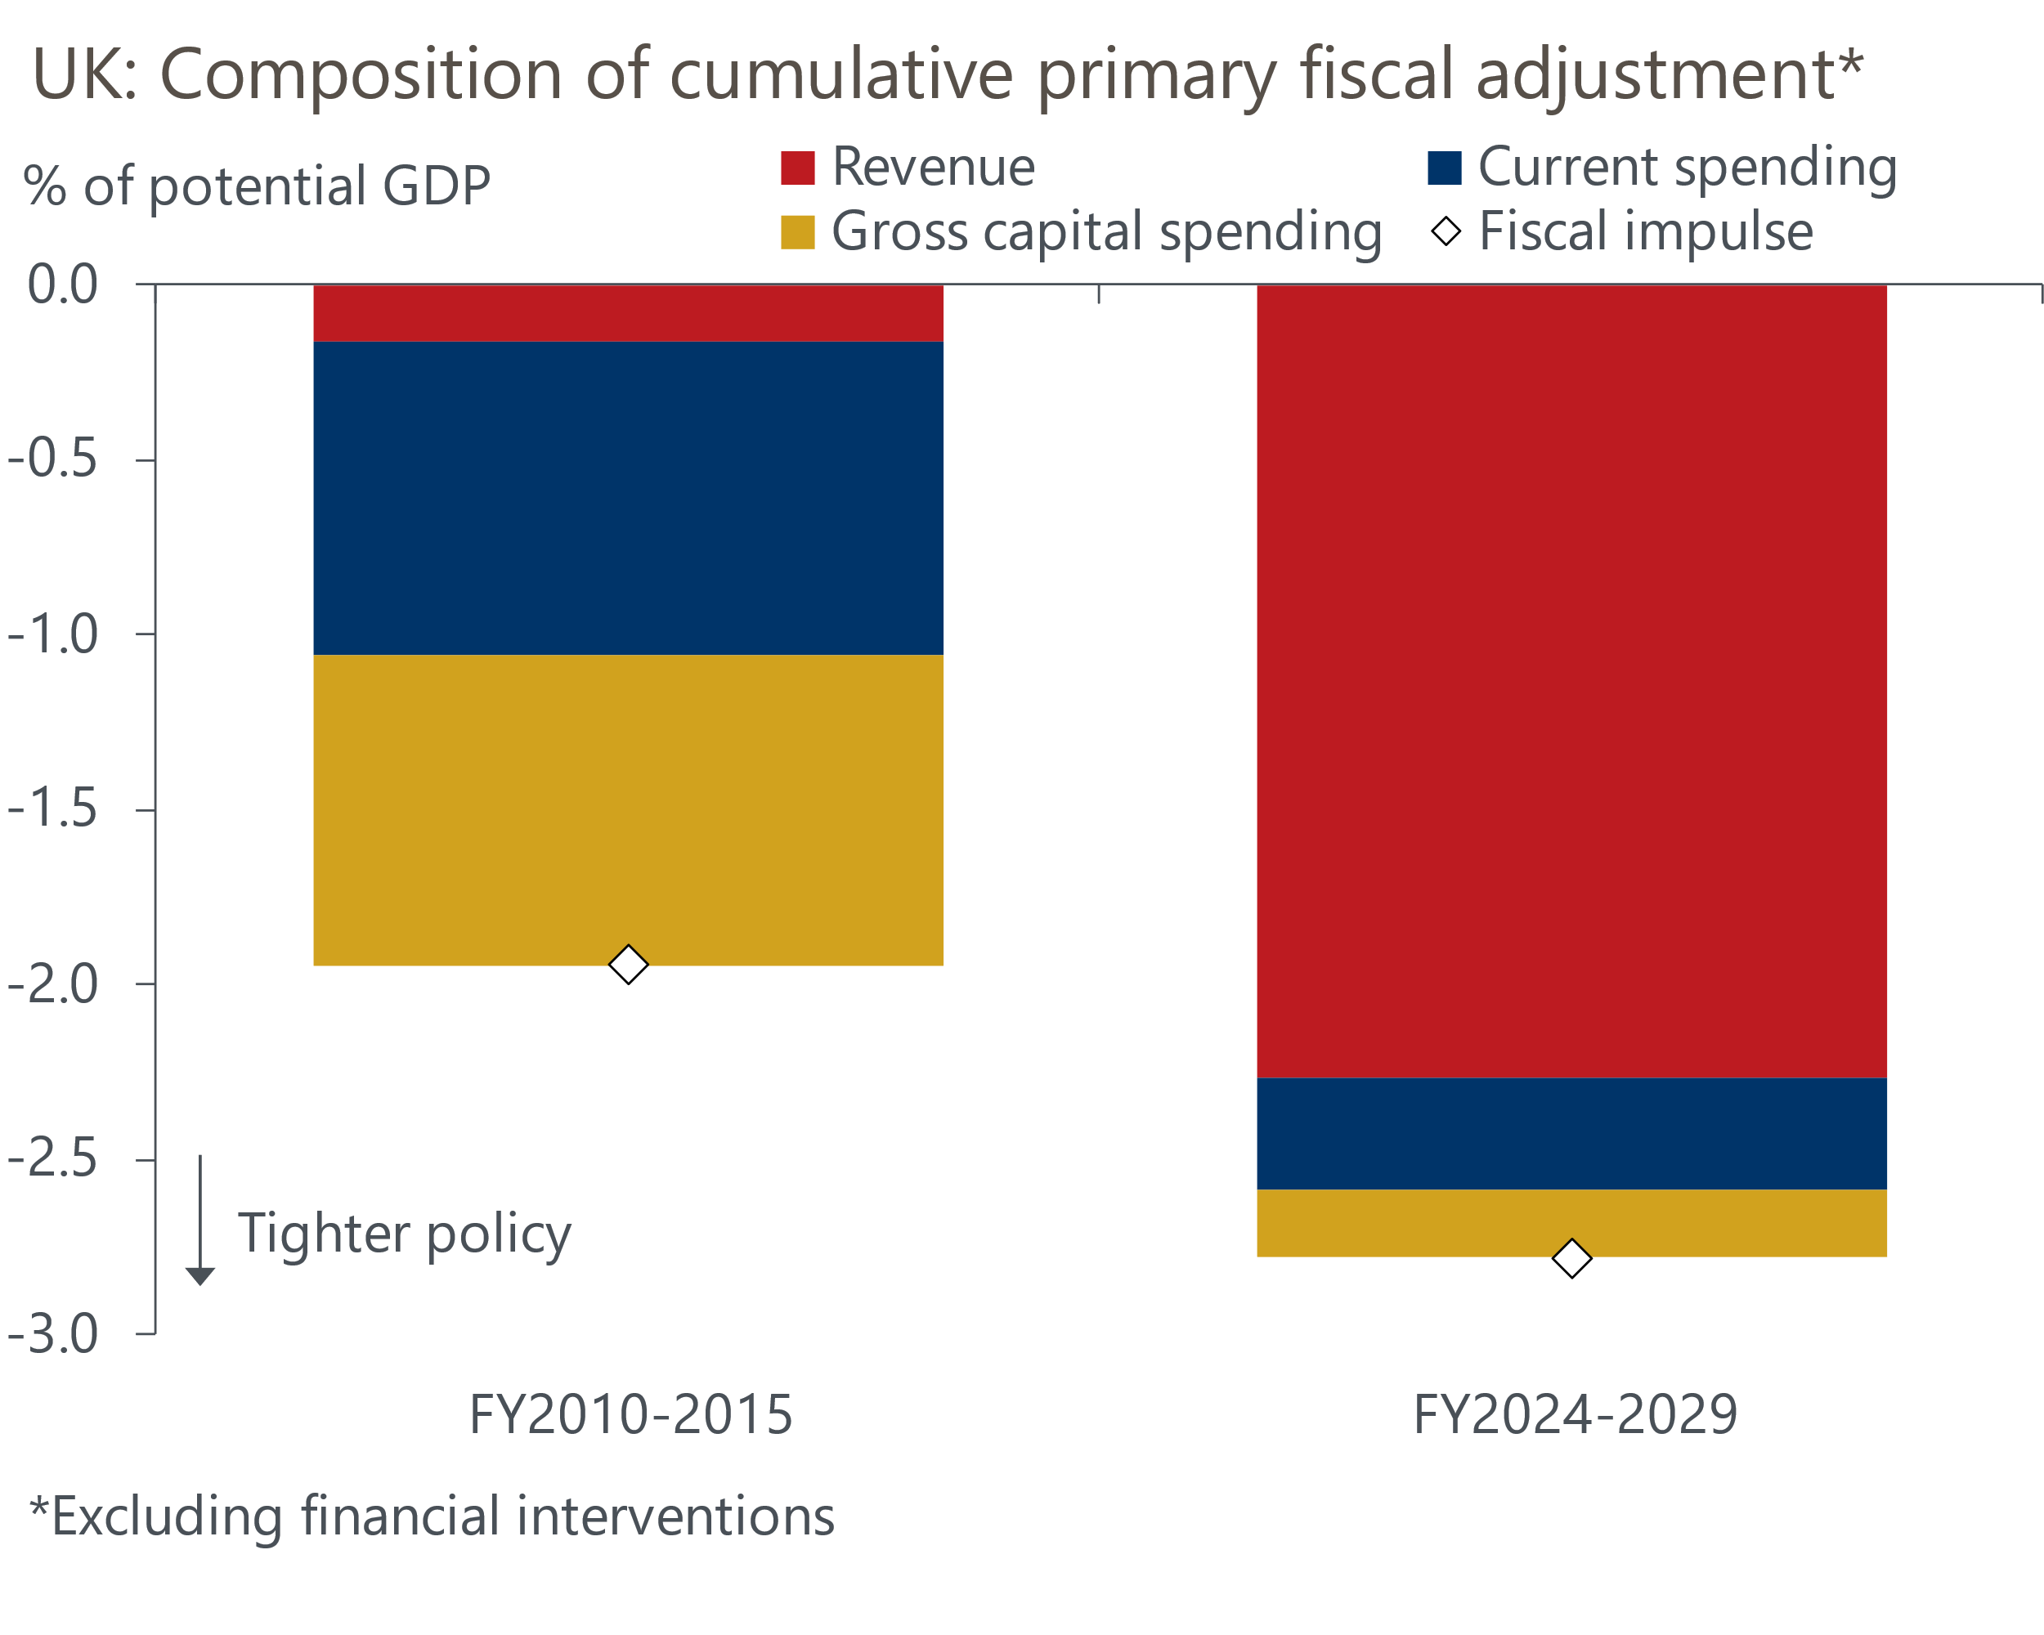
Source: Oxford Economics, Haver Analytics
Our estimate of the fiscal adjustment in the current parliament is much higher than the Office for Budget Responsibility's October estimate of 2.2% over the same period. The discrepancy largely stems from our less optimistic outlook for potential output growth.

What makes for a successful fiscal adjustment? The evidence
The Autumn Budget was intended to provide a framework for fiscal policy over the next five years. But how likely is it that the planned fiscal adjustment will succeed? There is a large body of international evidence on what factors make for a successful fiscal adjustment. The main conclusions are:
- The failure rate of fiscal adjustment efforts is high at around 50%
- Design is important. The division between spending cuts and revenue increases (including tax rises) is an important factor determining whether adjustments are successful
- Growth outcomes of fiscal adjustments vary significantly depending on design and on additional supportive policies or external factors
Success and failure of adjustments. Even studies which are generally upbeat about the outcomes of fiscal adjustments find a relatively high failure rate. The study of 52 adjustments in 1970-2010 by Alesina and Ardagna shows that only around half of the adjustments were 'successful' on the basis of the debt-to-GDP ratio being lower two years after the adjustment ended, compared to its level in the final year of the adjustment (Chart 3).
In a similar vein, Tsibiouris et al. find that only 66 of 155 (i.e. around 40%) of large fiscal adjustments studied over three decades were sustained (defined as cases where less than a fifth of the adjustment was reversed). The study of European fiscal adjustments by Mauro finds some plans were derailed almost immediately by external shocks and that planned spending cuts often failed to materialise.
Our analysis of 17 further fiscal adjustments in advanced economies after the global financial crisis shows similar results to the studies of earlier periods. Using the same criterion as Alesina and Ardagna we found a roughly even split between successful and unsuccessful adjustments.
Chart 3: Fiscal adjustments have a high failure rate
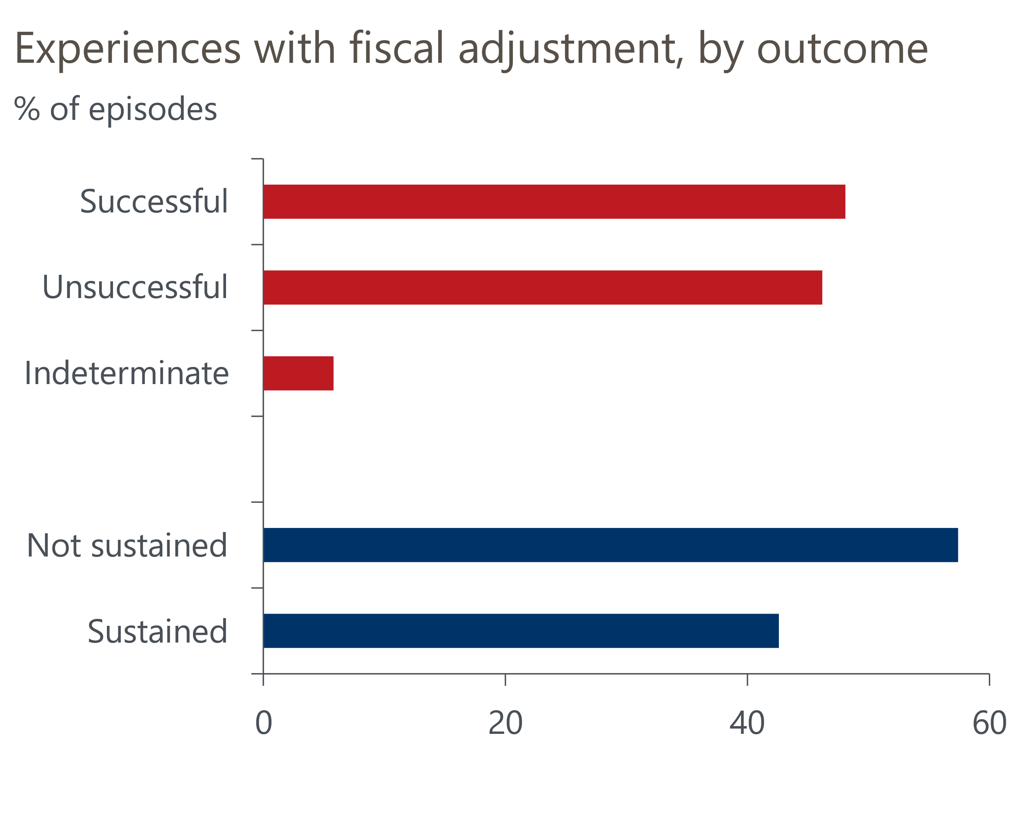
Source: Alesina & Ardagna (2012), Tsibouris et al. (2006)
The design of fiscal adjustments. A number of studies suggest that fiscal adjustments centred on expenditure reductions, rather than revenue increases, have a better chance of success. Alesina and Ardagna's 2012 study found that successful adjustments had around a 70% share of spending cuts in the total adjustment, while for unsuccessful adjustments the share was just 45%.
Similarly, the study of over 300 episodes by Tsibouris et al. found that sustained adjustments had a 75%-25% ratio between spending cuts and revenue rises, while reversed adjustments had a 50%-50% share. Both studies suggest the role of reductions in current government spending (including the government wage bill) is particularly important. This is probably on the basis that spending cuts in this area may be of a permanent nature, whereas large tax-driven adjustments have the potential to blunt incentives, distort prices, and drive up labour costs, which hits both international competitiveness and confidence.
Our own analysis of 17 fiscal adjustments after the global financial crisis shows similar results to the earlier studies. In our sample, successful adjustments (based on the same criterion as the Alesina and Ardagna study) had a 60%-40% spending cuts to revenue raising split, while unsuccessful adjustments had a 13%-87% split.
Chart 4: Expenditure-based adjustments tend to be more successful
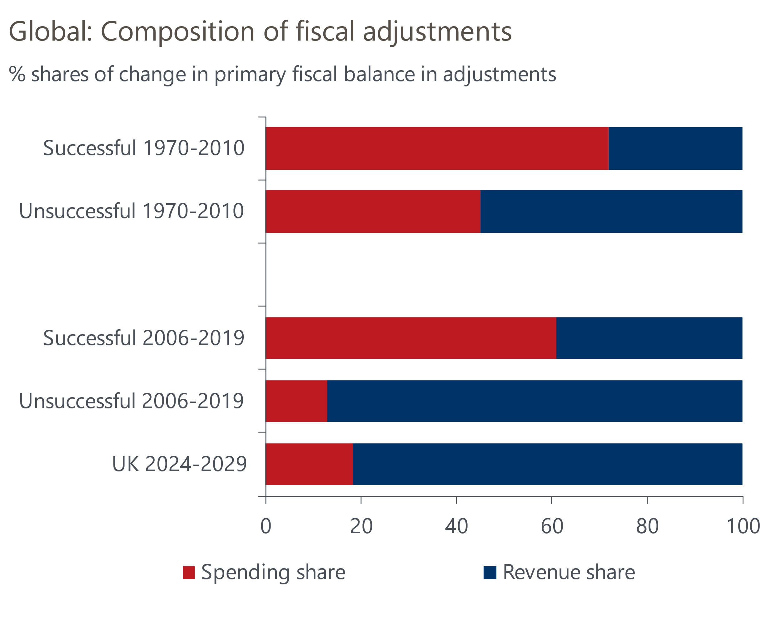
Source: Oxford Economics, Alesina & Ardagna (2012). For definitions of different kinds of adjustments see text
The evidence on failure rates of adjustments and the different outcomes of revenue-based and expenditure-based adjustments emphasises the need for the UK authorities to carefully design their adjustment programme.
In this context, our estimate of the split between revenue and spending measures in the current programme is of some concern. We estimate that just over 80% of the planned reduction in the structural primary deficit is expected to come from revenue-raising measures – a proportion similar to that seen in our sample of failed adjustments since 2006 (Chart 4).
Growth outcomes, external factors, and supportive policies. The evidence on the importance of supportive policies and helpful external conditions is mixed but overall suggests these factors are important. A contractionary fiscal adjustment could be substantially ameliorated by factors such as rapid global growth, exchange rate depreciation, or expansionary monetary policy, raising its chances of success. Similarly, a strong accompanying package of structural reforms that boosts the supply side of the economy could help a fiscal adjustment to succeed.
More controversially, it is sometimes argued that fiscal adjustments can be expansionary. The usual reasoning here is that negative Keynesian effects of adjustments can be offset by other effects such as 'credibility effects' like the reduction of risk premia embodied in long-term rates (potentially helping to reverse 'crowding out' effects), boosts to business and consumer confidence, and positive impacts on labour markets and competitiveness.
We think it's likely that such cases are rare, with some of the channels by which expansionary fiscal adjustments are supposed to work only likely to function in quite extreme situations with very high risk premia and rock-bottom levels of private sector confidence. Our sample of fiscal adjustments from 2006-2019 finds only very marginally better growth than the G7 average for 'successful' fiscal adjustments. More convincing though is the evidence on the different growth outcomes between successful and unsuccessful fiscal adjustments. Successful adjustments are associated with considerably better growth outcomes, even when correcting for world growth (Chart 5).
Chart 5: Big growth differences between adjustments
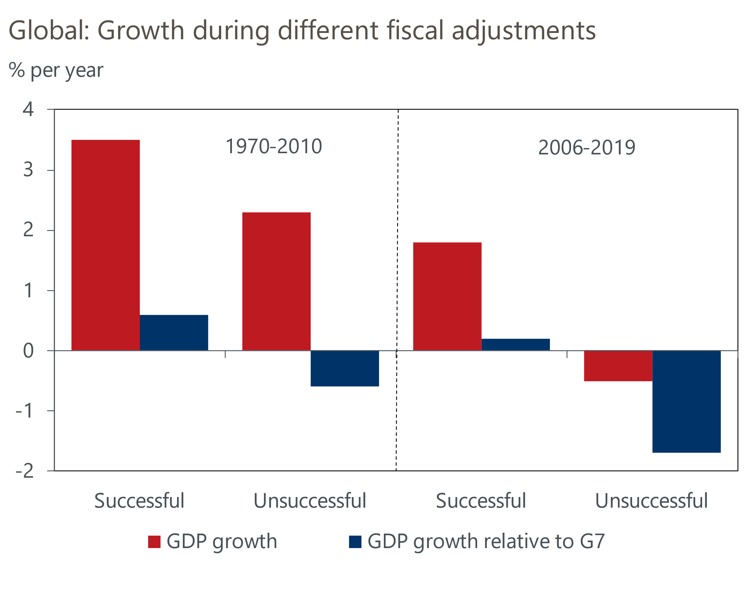
Source: Oxford Economics, Alesina & Ardagna (2012)

We've assessed the UK's adjustment plans
Based on the international evidence, we think prospects for the success of the UK's fiscal adjustment programme look unpromising.
The heavy emphasis on revenue-raising measures versus expenditure cuts is a concern. There are a few historical examples of revenue-led adjustments succeeding, such as the Spanish adjustment in 2009-2014, the Czech adjustment in 2009-2012, and the well-known Danish case in 1982-1986. But the success rate of adjustments structured like this is low – we found only three successful cases out of eleven in the 2006-2019 period. In the 1980s Danish case, its success was partly due to positive associated factors – export markets grew strongly (important for a very open economy), bond yields fell sharply in 1985-1986, and there is some evidence of positive credibility effects (a rise in taxes today raising expectations of a stabilisation of the future tax burden).
In the UK's case today, it is not obvious that external or supportive domestic policies will do much to raise the fiscal adjustment's chances of success. We expect the UK's export markets to grow at a fairly modest pace of around 2.7% per year from 2025-2029 (with considerable uncertainty around this, given risks related to tariff wars) and long-term bond yields to decline only gradually. Policy rates are likely to remain restrictive, above our estimate of the neutral rate of 2.5%, for a prolonged period.
The possibility of UK growth being boosted by a big positive credibility shock that reduces risk premia or boosts private sector confidence looks remote. Finally, there are few signs that the UK's fiscal adjustment plans will be helped by a programme of growth-boosting structural reforms. While there have been some positive announcements related to planning and infrastructure, we're sceptical that the government's supply-side plans will have much of an impact on potential output in the current parliament.

But alternative consolidation paths face practical constraints
Our analysis above suggests the UK's current fiscal adjustment plans are unlikely to succeed. Our baseline forecast shows GDP growth well below the Office for Budget Responsibility's projections over the next two years. We also expect balance sheet measures – including the new target measure, Public Sector Net Financial Liabilities – to continue to deteriorate over the next couple of years.
Still, there's also significant practical and political challenges associated with pursuing an alternative path for consolidation. Unprotected departments already face real terms spending cuts in the second half of the parliament – increasing the scale of these cuts would be difficult to achieve, particularly given the UK's long-running public sector productivity problem. Moreover, large cuts to spending totals would also be difficult to square with Labour's manifesto pledges to improve the level of funding for public services. Capital spending is already low by international standards, and cutting this further would risk repeating the mistakes of 2010-2015.
This serves to highlight the importance of the current government making tangible progress towards improving public sector productivity – this would be the key to reducing future current spending requirements and lessen the need for tax rises.

